**JENKINS TASK-1**

**Jenkins installed: -**

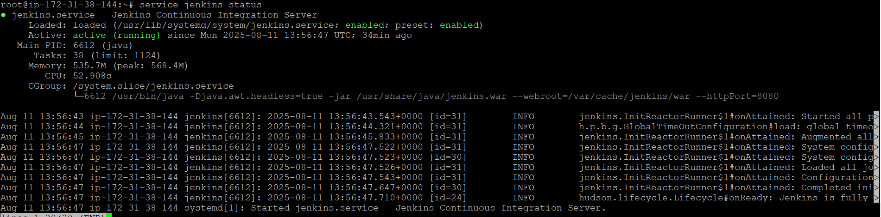

**Jenkins user created: -**

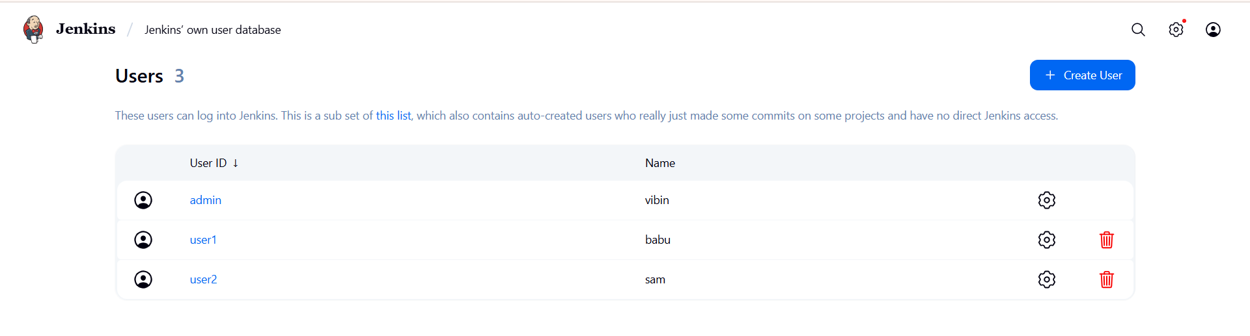

**Role-Based Strategy: -**

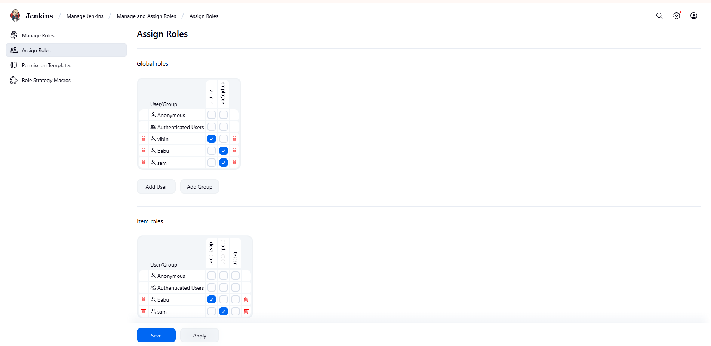

**Build a job: -**

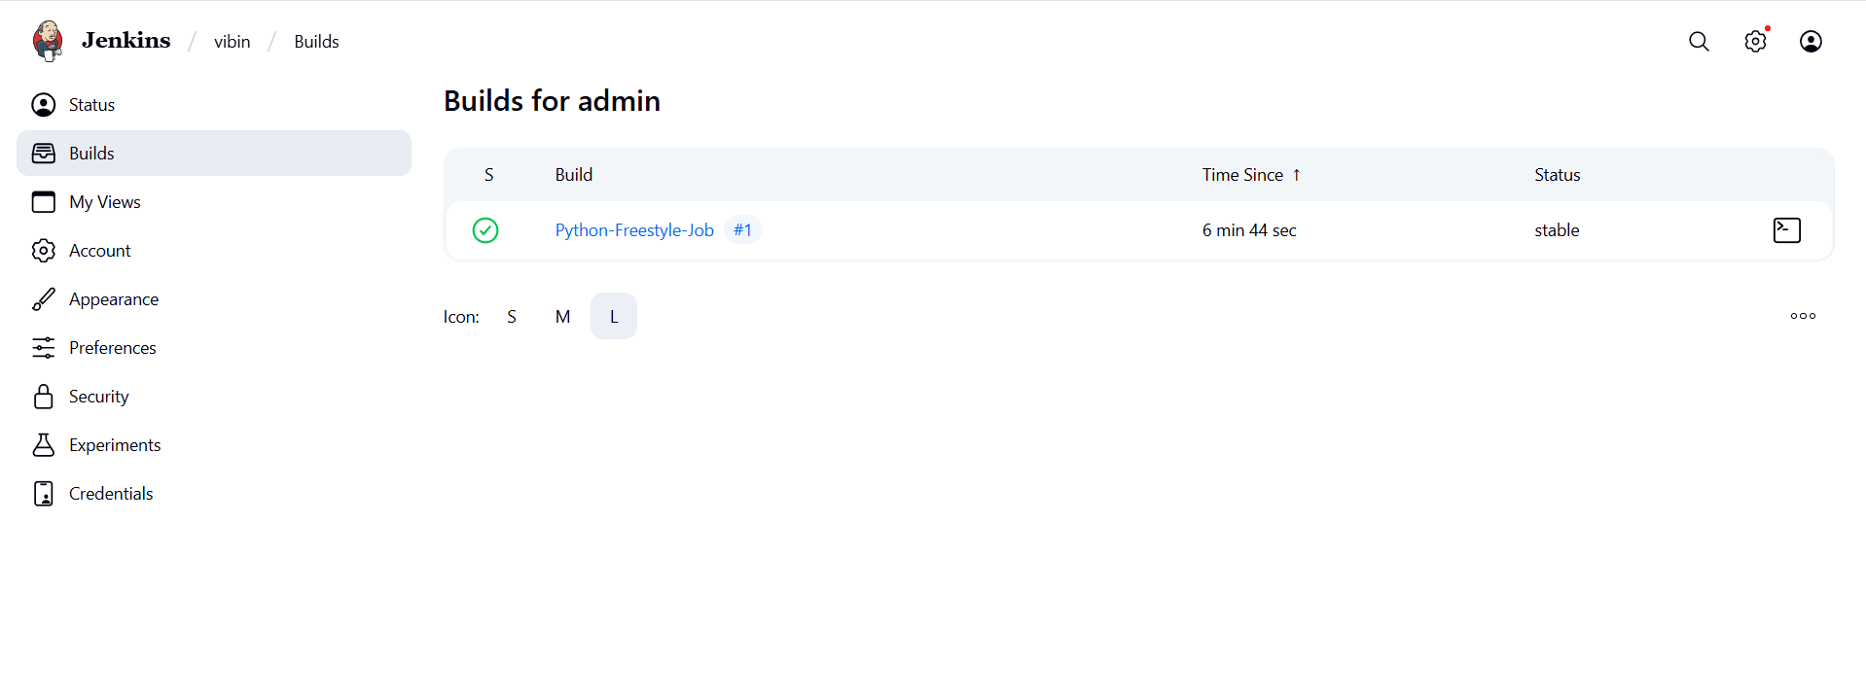

**Console Output: -**

